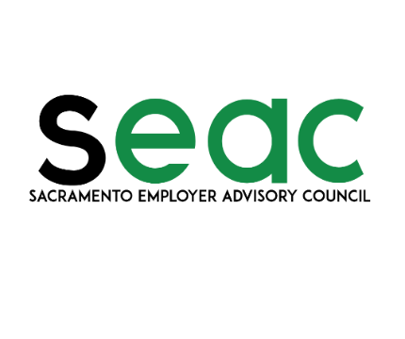

2021 SEAC Calendar
Inspiring Leadership Innovation

Date | Topic | Time
Jan 19 | Webinar: Workers’ Compensation 101 | 12:00 – 1:30 PM
Feb 16 & 17 | Webinar: Recruitment, Hiring, Retention and Termination | 12:00-1:30 PM
Mar 2 | Webinar: Paid Family Leave From EDD | 12:00 – 1:00 PM
Mar 16 | Webinar: ACA Compliance | 12:00-1:30 PM
Apr 20 | Webinar: OSHA/132 | 12:00 – 1:30 PM
May 18 | Workshop: Wage and Hour | 9:00 AM- 1:30 PM
Jun 15 | Luncheon: Return to Work | 11:00 -1:00 PM
Jul 20 | Luncheon: Employee Engagement | 11:00 – 1:00 PM
Aug 17 | Coffee With An Attorney | 9:00 – 10:30 AM
Sep 21 | Workshop: Investigations - What, How and Who | 9:00 AM- 1:30 PM
Nov 16 & 17 | Webinar: Sexual Harassment Prevention | 12:00 – 2:00 PM
Dec 14 | Webinar: Legal Updates 2022 | 12:00-1:30 PM

- Dates, times and topics are subject to change.
- Workshops and luncheon meetings are held at: Citrus Heights City Hall, 6360 Fountain Square Drive, Citrus Heights, CA 95621.
- Dates, locations, and registration costs for meetings and workshops available at our website: www.saceac.com.
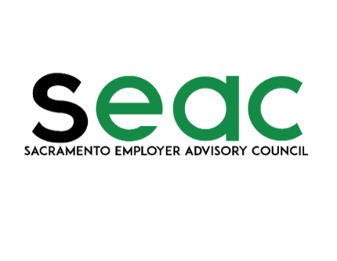

2021 SEAC Calendar
Inspiring Leadership Innovation

Date | Topic | Time
Jan 19 | Webinar: Workers’ Compensation 101 | 12:00 – 1:30 PM
Feb 16 & 17 | Webinar: Recruitment, Hiring, Retention and Termination | 12:00 – 1:30 PM
Mar 2 | Webinar: Paid Family Leave From EDD | 12:00 – 1:30 PM
Mar 16 | Webinar: ACA Compliance | 12:00 – 1:30 PM
Apr 20 | Webinar: OSHA/132 | 12:00 – 1:30 PM
May 18 | Workshop: Wage and Hour | 9:00 – 1:30 PM
Jun 15 | Luncheon: Return to Work | 11:00 – 1: 00 PM
Jul 20 | Luncheon: Employee Engagement | 11:00 – 1:00 PM
Aug 17 | Coffee With An Attorney | 9:00 – 10:30 AM
Sep 21 | Workshop: Investigations – What, How and Who | 9:00 – 1:30 PM
Nov 16 & 17 | Webinar: Sexual Harassment Prevention | 12:00 – 2:00 PM
Dec 14 | Webinar: Legal Updates 2022 | 12:00- 1:30PM

- Dates, times and topics are subject to change.
- Workshops and luncheon meetings are held at: Citrus Heights City Hall, 6360 Fountain Square Drive, Citrus Heights, CA 95621.
- Dates, locations, and registration costs for meetings and workshops available at our website: www.saceac.com.

2021 SEAC Calendar
Inspiring Leadership Innovation

Date | Topic | Time
Jan 19 | Webinar: Workers’ Compensation 101 | 12:00 – 1:30 PM
Feb 16 & 17 | Webinar: Recruitment, Hiring, Retention and Termination | 12:00 – 1:30 PM
Mar 2 | Webinar: Paid Family Leave From EDD | 12:00 – 1:30 PM
Mar 16 | Webinar: ACA Compliance | 12:00 – 1:30 PM
Apr 20 | Webinar: OSHA/132 | 12:00 – 1:30 PM
May 18 | Workshop: Wage and Hour | 9:00 – 1:30 PM
Jun 15 | Luncheon: Return to Work | 11:00 – 1:30 PM
Jul 20 | Luncheon: Employee Engagement | 11:00 – 1:30 PM
Aug 17 | Coffee With An Attorney | 9:00 – 10:30 AM
Sep 21 | Workshop: Investigations – What, How and Who | 9:00 – 1:30 PM
Nov 16 & 17 | Webinar: Sexual Harassment Prevention | 12:00 – 2:00 PM
Dec 14 | Webinar: Legal Updates 2022 | 12:00 – 1:30 PM

- Dates, times and topics are subject to change.
- Workshops and luncheon meetings are held at: Citrus Heights City Hall, 6360 Fountain Square Drive, Citrus Heights, CA 95621.
- Dates, locations, and registration costs for meetings and workshops available at our website: www.saceac.com.

Sacramento Employer Advisory Council (SEAC), in close partnership with the EDD and the California Employer Advisory Council (CEAC), provides its members with valuable employment law updates and practical HR guidance for complying with the complex web of federal and state employment laws. SEAC is not only a vital resource for the continuing education needs of its members, but it also assists its members in obtaining the information and assistance they need from the EDD. ‘Solid, Essential, Accurate, & Competent’ – that’s the kind of information members get from SEAC. Join us – we look forward to meeting you.

SEAC Benefits Include:

- Membership discounts for SEAC breakfasts, luncheons and workshops on important topics for Employment Law and HR professionals;

- Continuing education, including HRCI, SHRM and MCLE credits for SEAC presentations;

- Free, interactive webinars on “hot” legal and HR topics, available from the comfort of your home or office;

- Free monthly legal updates with information on new legislation, regulations, and cases affecting California employers;

- Access to an EDD representative at every SEAC function with guidance on EDD services and information;

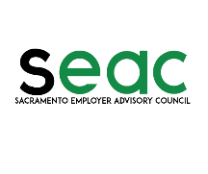

Sacramento Employer Advisory Council (SEAC), in close partnership with the EDD and the California Employer Advisory Council (CEAC), provides its members with valuable employment law updates and practical HR guidance for complying with the complex web of federal and state employment laws. SEAC is not only a vital resource for the continuing education needs of its members, but it also assists its members in obtaining the information and assistance they need from the EDD. ‘Solid, Essential, Accurate, & Competent’ – that’s the kind of information members get from SEAC. Join us – we look forward to meeting you.

SEAC Benefits Include:

- Membership discounts for SEAC breakfasts, luncheons and workshops on important topics for Employment Law and HR professionals;

- Continuing education, including HRCI, SHRM and MCLE credits for SEAC presentations;

- Free, interactive webinars on “hot” legal and HR topics, available from the comfort of your home or office;

- Free monthly legal updates with information on new legislation, regulations, and cases affecting California employers;

- Access to an EDD representative at every SEAC function with guidance on EDD services and information;

Sacramento Employer Advisory Council (SEAC), in close partnership with the EDD and the California Employer Advisory Council (CEAC), provides its members with valuable employment law updates and practical HR guidance for complying with the complex web of federal and state employment laws. SEAC is not only a vital resource for the continuing education needs of its members, but it also assists its members in obtaining the information and assistance they need from the EDD. ‘Solid, Essential, Accurate, & Competent’ – that’s the kind of information members get from SEAC. Join us – we look forward to meeting you.

SEAC Benefits Include:

- Membership discounts for SEAC breakfasts, luncheons and workshops on important topics for Employment Law and HR professionals;

- Continuing education, including HRCI, SHRM and MCLE credits for SEAC presentations;

- Free, interactive webinars on “hot” legal and HR topics, available from the comfort of your home or office;

- Free monthly legal updates with information on new legislation, regulations, and cases affecting California employers;

- Access to an EDD representative at every SEAC function with guidance on EDD services and information;

